**[IS216] Extra Exercises - Week 2 - CSS Basics**

**Objectives**

● To understand how CSS enables styling of HTML elements

* To apply the use of CSS to HTML web pages.

**Instructions**

● Questions with no asterisk mark are easy peasy.

● Questions marked with * are slightly challenging.

● Questions marked with **\***\* are challenging.

● Questions marked with *** are very challenging.

**Download**

● **Resources**: Click [here](https://smu-my.sharepoint.com/:f:/g/personal/lkshar_smu_edu_sg/EuBHipqeS51DkBkdslIfYXYBTscrvMhbcqaZT3_fSjmseg?e=o7vjR1)

* **Sample Solutions:** Click [here](https://smu-my.sharepoint.com/:f:/g/personal/lkshar_smu_edu_sg/EsRTAah_4dFErzhpJqxkU20B2yJS7cc1oFd2kaB45IebOA?e=eyLllv)

**NOTE:** If you spot any mistakes/errors in the questions, please contact your instructors by email and state the issues. We will try to address it as soon as possible.

# 

**Question 1 – Fruit (*)**

Go to fruit directory.

|--fruit

|-- apple.jpg

|-- fruit.html (to do)

|-- fruit-pic.jpg

Complete fruit.html with appropriate CSS styling such that the following will be displayed on a web browser. This web page has a side menu bar that will not scroll with the content on the right.

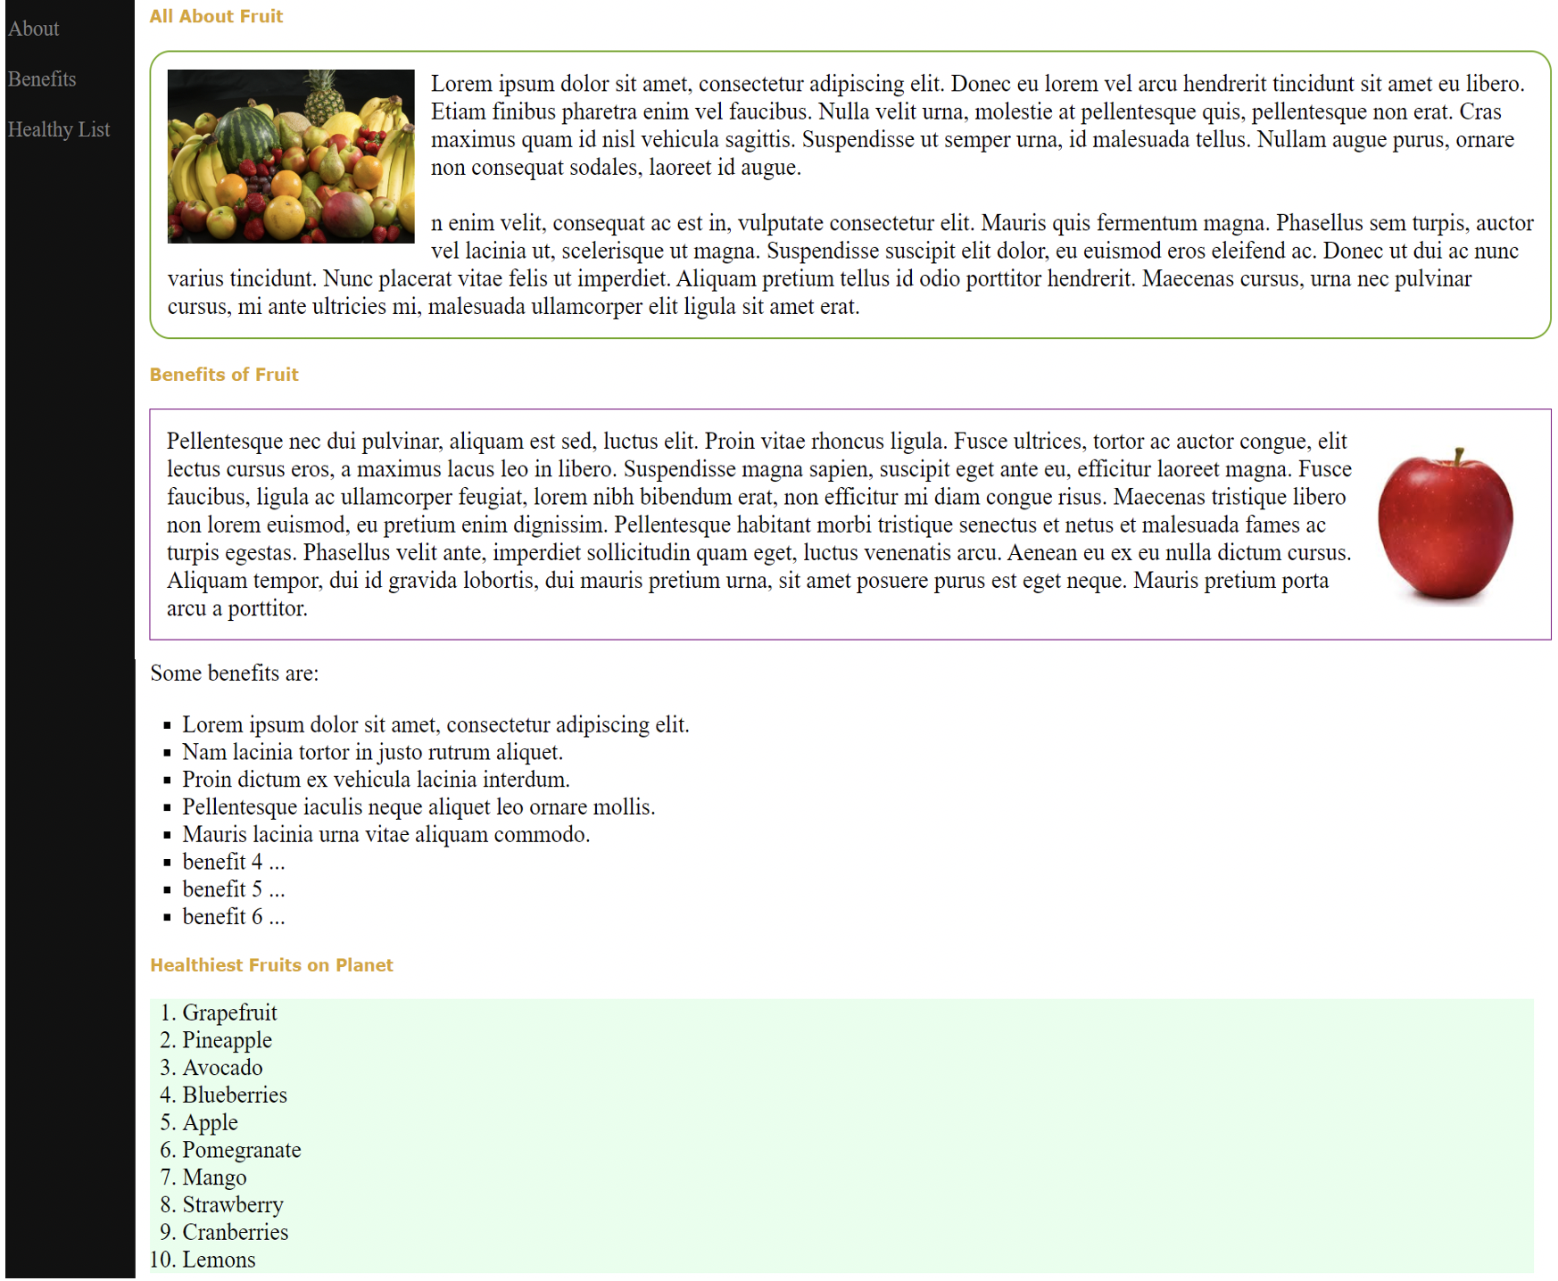

**Question 2 – Learn (*)**

Go to learn directory.

|-- learn

|

|-- images

|-- {various images}

|

|-- learn.html

|

1. Complete learn.html with appropriate CSS styling such that the following will be displayed on a web browser (in the main box)

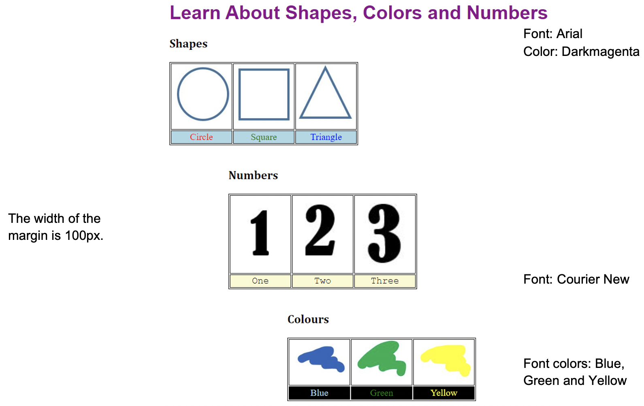

2. The font size of the row in the table will increase to 30px when the user does a mouse over.

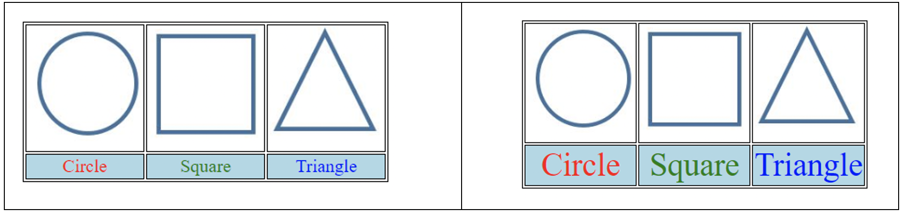

**Question 3 – Marketplace (**)**

Go to marketplace directory.

|-- marketplace

|

|-- images

|-- coffee.jpg

|-- fruit.jpg

|-- marketplace.jpg

|-- veg.jpg

|

|-- marketplace.html

|

1. Complete marketplace.html with appropriate CSS styling such that the following will be displayed on a web browser.

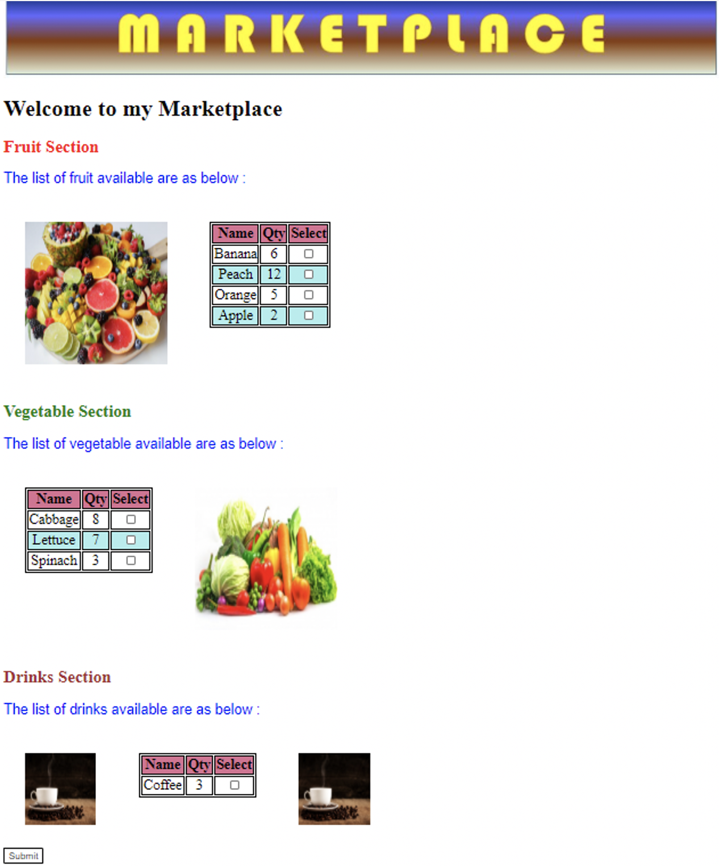

2. To make the web page more interesting, use CSS to display a blue color box with a white tick when the user clicks on each checkbox. An example is shown below.

